**Dashboard elements and Actions (URL)**

If we take URL Action on Dashboard first we need to take some of the steps:

1. Create State wise Sales on Map.
2. Take sheet on dashboard.
3. Copy the URL of the state in country (<https://en.wikipedia.org/wiki/Welcome,_Texas>)
4. Go to Dashboard take URL (Web Page)
5. Paste the URL of state in country
6. Go to Dashboard Action
7. Name of the action , Source Sheet ,Select ,URL (<https://en.wikipedia.org/wiki/Welcome,_Texas>)

Here in URL last ----Welcome,Texas delete these state instead of that Add field name as State and URL target automatically selected.

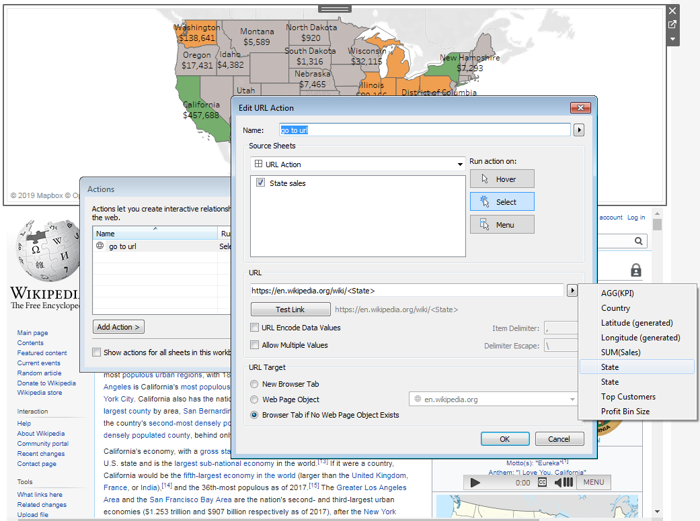

Here in dashboard if we select any state it will automatically navigate to state wise in next sheet.

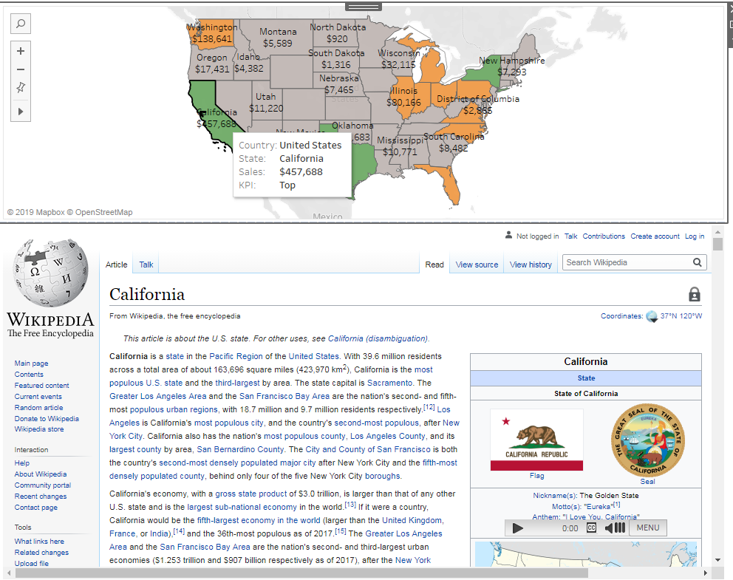

If we select any state Wikipedia opens on that state wise because of that URL Action.